**DISCRETE MATHEMATICS – FALL 2019**

**Final Exam – Code 02**

**90 minutes**

**ID:** …………………  **Name:** ……………………………………………….. **Class:** …………

**Instructions:** Fill in your student ID, name and class. Then submit this paper along with your answer at the end of the exam.

**Question 1:**

Prove the triangle inequality, which states that if *x* and *y* are real numbers, then

|*x*| + |*y*| ≥ |*x* + *y*| (where |*x*| represents the absolute value of *x*, which equals *x* if *x* ≥ 0 and equals -*x* if *x <* 0).

**Question 2:**

a) Find an inverse of 101 mod 4620

c) Solve the congruence 200*x* ≡ 13 *(*mod 1001*)*

**Question 3:**

Use Bellman Ford’s algorithm to find the shortest paths and their length from S to other vertices.

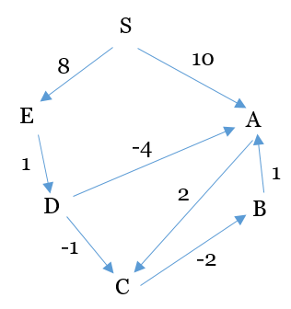

**Question 4:**

Are the simple graphs with the following adjacency matrices isomorphic?

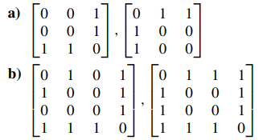

**Question 5:**

The roads represented by this graph are all unpaved. The lengths of the roads between pairs of towns are represented by edge weights. Which roads should be paved so that there is a path of paved roads between each pair of towns so that a minimum road length is paved? Explain in detail.

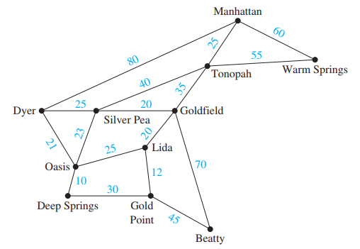

***-----The end-----***